Part II: SPSS Analysis
Module/Week 8 Exercise File 1

Open the “Module/Week 8 Exercise File 1” document (found in the course’s Assignment Instructions folder) in order to complete these exercises.

Part II:
Exercises 1-3
Use file: Module/Week 8 Exercise File 1

- The anger scores for 6 fictional Marines following a month-long exercise are entered in the Module/Week 8 Exercise File 1 document (found in the Assignment Instructions folder).
- Using these data, run 3 single-sample t-tests to compare the Marines’ mean anger score to the following population values:

Population mean anger scores
Population of college men: μ = 7.9
Population of adult men: μ = 9.2
Population of male psychiatric outpatients: μ = 14.6
- For each test, paste the output and write a Results section in current APA style
  - As demonstrated in the presentation and in the textbooks.
- There will be 3 sets of output and 3 results sections using this data set
  - 1 for each test involving a different population mean.

 | 1-a) | Population of college men: μ = 7.9.
Answer: SPSS output of the t-Test

One-Sample Statistics
 | N | Mean | Std. Deviation | Std. Error Mean
anger_score | 6 | 13.33 | 1.211 | .494

One-Sample Test
 | Test Value = 7.9
 | t | df | Sig. (2-tailed) | Mean Difference | 95% Confidence Interval of the Difference
 |  |  |  |  | Lower | Upper
anger_score | 10.989 | 5 | .000 | 5.433 | 4.16 | 6.70

 | 1-b) | Write a results section in current APA style describing the outcome.  All homework results sections must follow the example given in the SPSS presentation. Results sections are paragraphs and must include the APA-formatted statistical statement.
 | Answer
 | 2-a) | Population of adult men: μ = 9.2.
Answer: SPSS output of the t-Test

One-Sample Statistics
 | N | Mean | Std. Deviation | Std. Error Mean
anger_score | 6 | 13.33 | 1.211 | .494

One-Sample Test
 | Test Value = 9.2
 | t | df | Sig. (2-tailed) | Mean Difference | 95% Confidence Interval of the Difference
 |  |  |  |  | Lower | Upper
anger_score | 8.360 | 5 | .000 | 4.133 | 2.86 | 5.40

 | 2-b) | Write a results section in current APA style describing the outcome. See (1b) for details.
 | Answer
 | 3-a) | Population of male psychiatric outpatients: μ = 14.6
Answer: SPSS output of the t-Test

One-Sample Statistics
 | N | Mean | Std. Deviation | Std. Error Mean
anger_score | 6 | 13.33 | 1.211 | .494

One-Sample Test
 | Test Value = 14.6
 | t | df | Sig. (2-tailed) | Mean Difference | 95% Confidence Interval of the Difference
 |  |  |  |  | Lower | Upper
anger_score | -2.562 | 5 | .051 | -1.267 | -2.54 | .00

 | 3-b) | Write a results section in current APA style describing the outcome. See (1b) for details.
 | Answer

Part III: SPSS Data Entry and Analysis
Data provided below.

Attitudes Toward
Technology Scale Scores
12
25
8
12
10
11
7
7
13
5
8
7
9
12
19
20
18
Part III:
Questions 1-2

Do elderly people have less positive attitudes toward technology than people in general?

A social psychologist assessed the attitudes of 17 elderly people using a scale where a lower score indicates a less positive attitude overall. The mean on this scale for the general population is 15.6. The data for the participants are shown in the table to the left.

Using SPSS, conduct a single-sample t-test to answer the social psychologist’s research question.

 | 1-a) | Paste appropriate tabular output here
Answer: SPSS output of the t-Test

One-Sample Test
 | Test Value = 15.6
 | t | df | Sig. (2-tailed) | Mean Difference | 95% Confidence Interval of the Difference
 |  |  |  |  | Lower | Upper
Attitudes Toward Technology Scale Score | -2.729 | 16 | .015 | -3.65882 | -6.5011 | -.8166

 | 1-b) | Paste appropriate SPSS graph here
Answer: SPSS graph

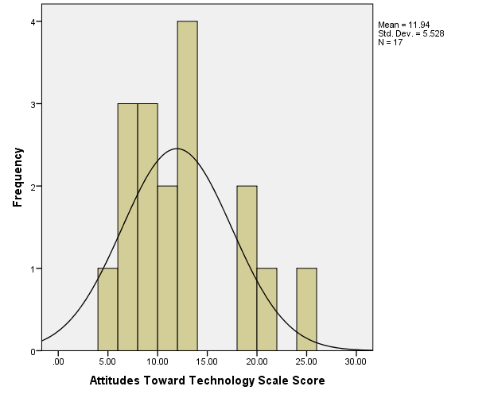

 | 2-a) | Write a results section in current APA style describing the outcome. Refer to earlier directions for details of what is expected.

